# **8.1** Build a Multi-Container Docker Application Locally

**Objectives:**

* Build container image and create an application locally.
* Modify the application and rebuild the image.
* Push the local image to Docker Hub.
* Build an application locally with Docker Hub Image.
* Delete the images locally.

**Part 1. Build an Application Locally**

1. Start Docker Desktop
2. Download file **voting_redis.zip** given online and unzip it.
3. Using command line, switch to directory **voting_redis**.
4. Understand the code files in this directory.
5. The following command uses the **docker-compose.yaml** file to create the container image, download the Redis image, and start the application.

$ docker compose up -d

1. Use the docker images command to see the created images. One image is downloaded from Microsoft repository, and one image is created locally. The **vote_front** image contains the front-end application. The **redis** image is the backend database service.

$ docker images

1. Run the docker ps command to see the running containers.

$ docker ps

1. To test your application locally, navigate to http://localhost:8080 in a web browser.

1. From Docker Desktop, delete the container.

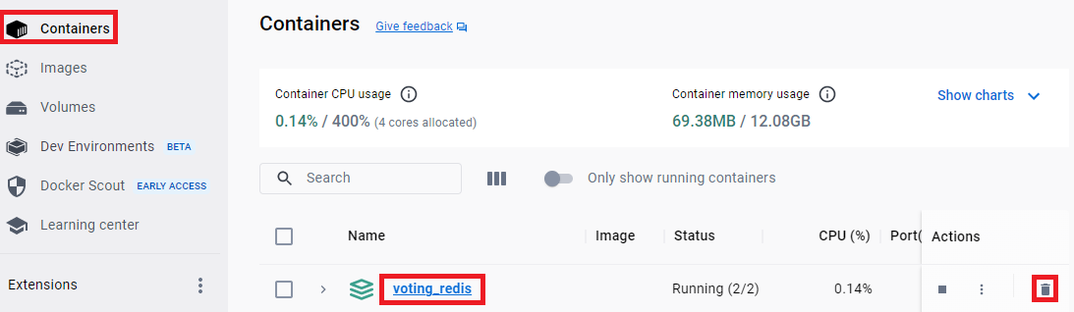

1. From Docker Desktop, delete the images.

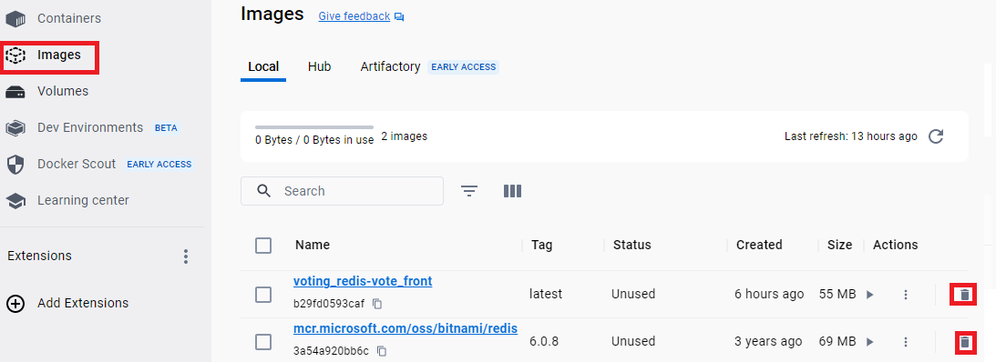

**Part 2. Modify the Application**

1. Modify the configuration file at voting_redis🡺vote🡺voting🡺 config_file.cfg, change ‘Owls’ to “Robots”. Save the changes.
2. Create new images with the following command.

**$ docker compose up -d**

1. Navigate to <http://localhost:8080>. You will see the new web page.

**Part 3. Push a local image to Docker Hub**

1. Sign into Docker hub from a web browser.
2. Click “Create repository”.

1. Repository name is same as your local image.

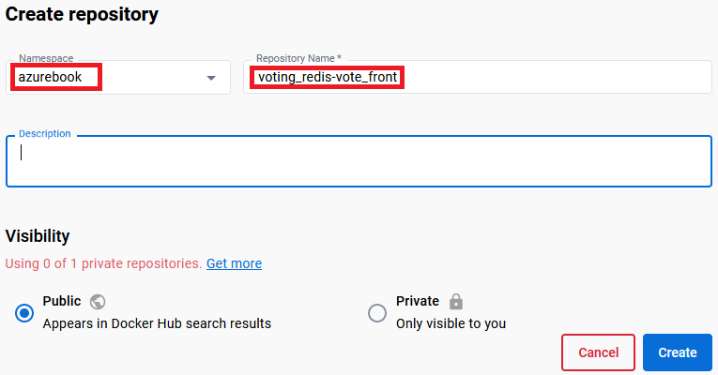

1. Sign into Docker hub from Docker Desktop.
2. From command line, use the docker tag command to associate your local image with the remote image. Replace YOUR-DID with your Docker ID (Namespace). In my case, YOUR-DID is **azurebook**.

**$ docker tag voting_redis-vote_front YOUR-DID/voting_redis-vote_front**

1. From command line, push the local image to Docker Hub.

**$ docker push YOUR-DID/voting_redis-vote_front**

1. From Docker hub web page, you can see the image.

1. From Docker Desktop, delete the container and delete all local images.
2. Note here, your remote image at Docker Hub is not deleted.

**Part 4. Build an Application locally with Docker Hub image**

1. Start Command Line.
2. Create a new directory, say voting2, on your local drive.
3. Download file **docker-compose.yaml** given online.

1. Open docker-compose.yaml with a text editor. Compared with the file given in Part 1, the build command line is replaced with an image source on Docker hub. See the two files below.

**Compose file used in Part 1:**

**Compose file used in Part 4:**

1. Execute the following command, which uses the docker-compose.yaml file to create the container image, download the Redis image, and start the application.

**$ docker compose up -d**

1. Use the docker images command to see the images. Two images are downloaded. The **vote_front** image contains the front-end application. The **redis** image provides the backend database service.

**$ docker images**

1. Here is the output.

1. Run the docker ps command to see the running containers.

**$ docker ps**

1. The output looks like the following.

1. To test your application, navigate to <http://localhost:8080> in a web browser.

1. From Docker Desktop, delete the container and delete all local images.